ALASKA DEPARTMENT OF LABOR AND WORKFORCE DEVELOPMENT

Hiring our Heroes Veterans’ Career Fair
Registration Form
Nov. 9, 2012

Name of contact individual:

Organization or company name:

Address:

Zip:

Phone:

Fax:

Email:

Website:

As a way to document hiring successes at our job fairs, please provide information for the following question(s):
Did you hire anyone from the 2011 Hiring Our Heroes, Veterans and Spouses Job Fair? Yes No If yes, how many?

Each booth space will have a six-foot table and two chairs available at no cost to the participant. Please list below any additional needs (power, extra chairs, etc.) that you may have.

Please complete this form and fax or email to:
Anchorage Job Center Midtown, Business Connection, 907.269.4819

Or contact Nancy Heckmann:
907.269.4774 or nancy.heckmann@ alaska.gov
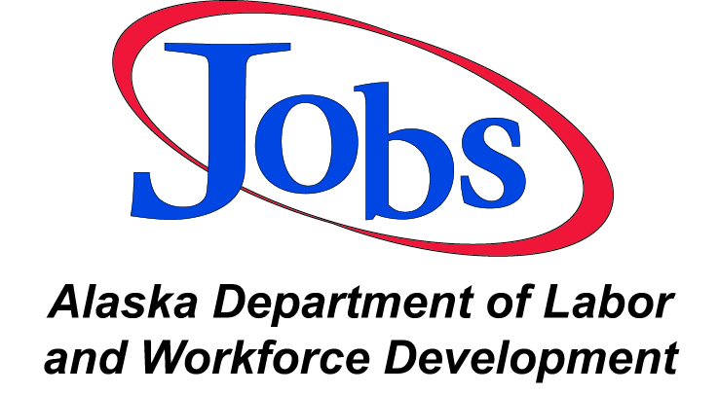

Thank you for your participation.

